**M Nauman Anwar**

**SU92-F24-BSAIM-214**

PROJECT1:

**Purpose**

This program analyzes a collection of movies and their budgets. It calculates the **average budget** and identifies which movies have a budget higher than the average.

### Features

1. **Calculate Average Budget**
   * The program sums all movie budgets and divides by the total number of movies.
2. **Find High-Budget Movies**
   * Movies with budgets greater than the average are displayed.
   * The program also shows **how much higher** each movie’s budget is compared to the average.
3. **Count Above-Average Movies**
   * Finally, the program counts and prints

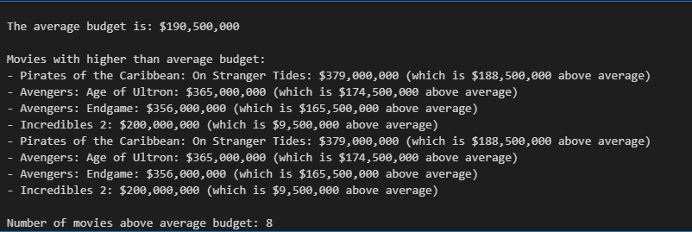

PROJECT 2:

**Purpose**

This program generates the classic **FizzBuzz sequence**, which is a popular programming exercise and interview question.

**Rules Implemented**

1. Print numbers starting from 1 in sequence.
2. If a number is divisible by **3**, print "Fizz".
3. If a number is divisible by **5**, print "Buzz".
4. If a number is divisible by **both 3 and 5**, print "FizzBuzz".
5. Otherwise, print the number itself.

